# Solve a matrix

https://www.khanacademy.org/math/precalculus/precalc-matrices/solving-equations-with-inverse-matrices/v/solving-matrix-equation

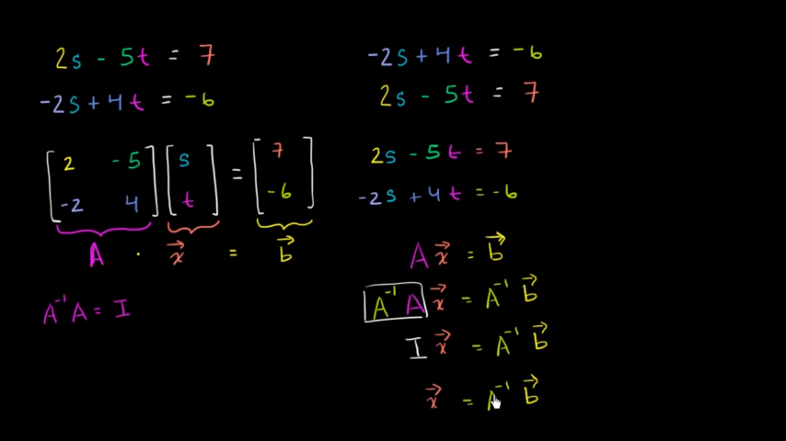

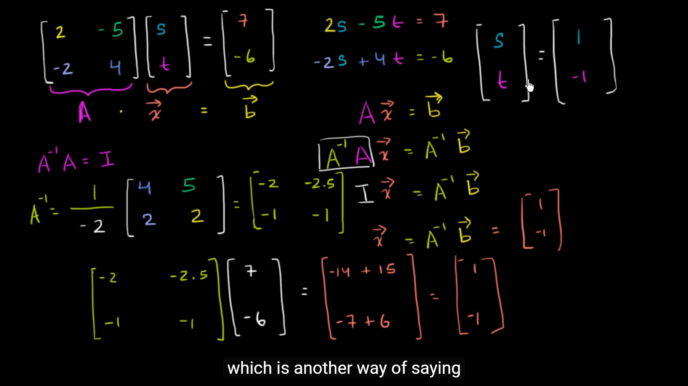

[**https://blog.csdn.net/qq_18343569/article/details/49834099**](https://blog.csdn.net/qq_18343569/article/details/49834099)

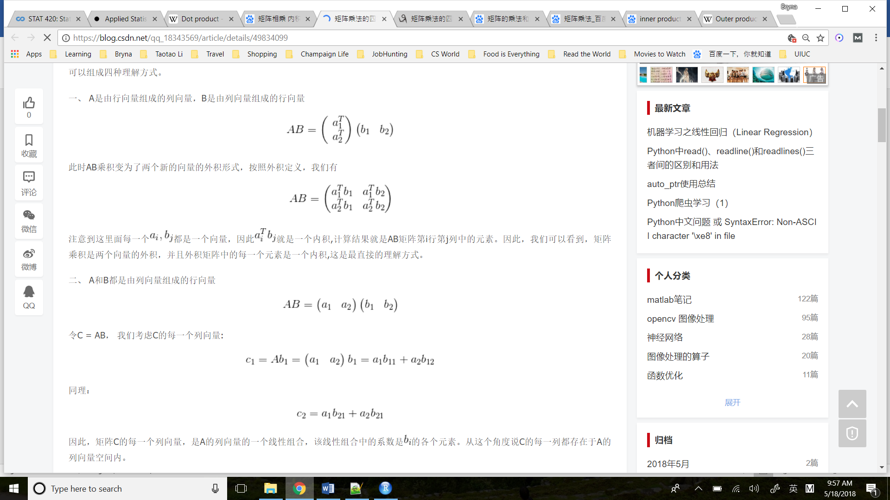

**Poisson Distribution**

[**https://www.khanacademy.org/math/statistics-probability/random-variables-stats-library/poisson-distribution/v/poisson-process-1**](https://www.khanacademy.org/math/statistics-probability/random-variables-stats-library/poisson-distribution/v/poisson-process-1)

# Introduction to t statistics

**If you are trying to construct a confidence interval for a sample mean, and you don’t know the true standard deviation of your population**

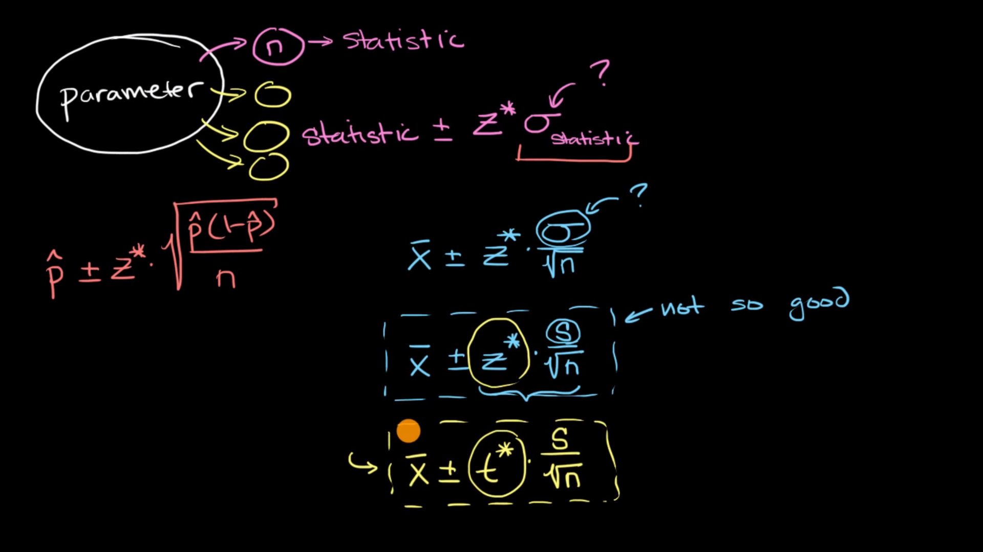

# Student’s t-test

t-value = signal / noise, numbers that tell me the difference between these two samples,

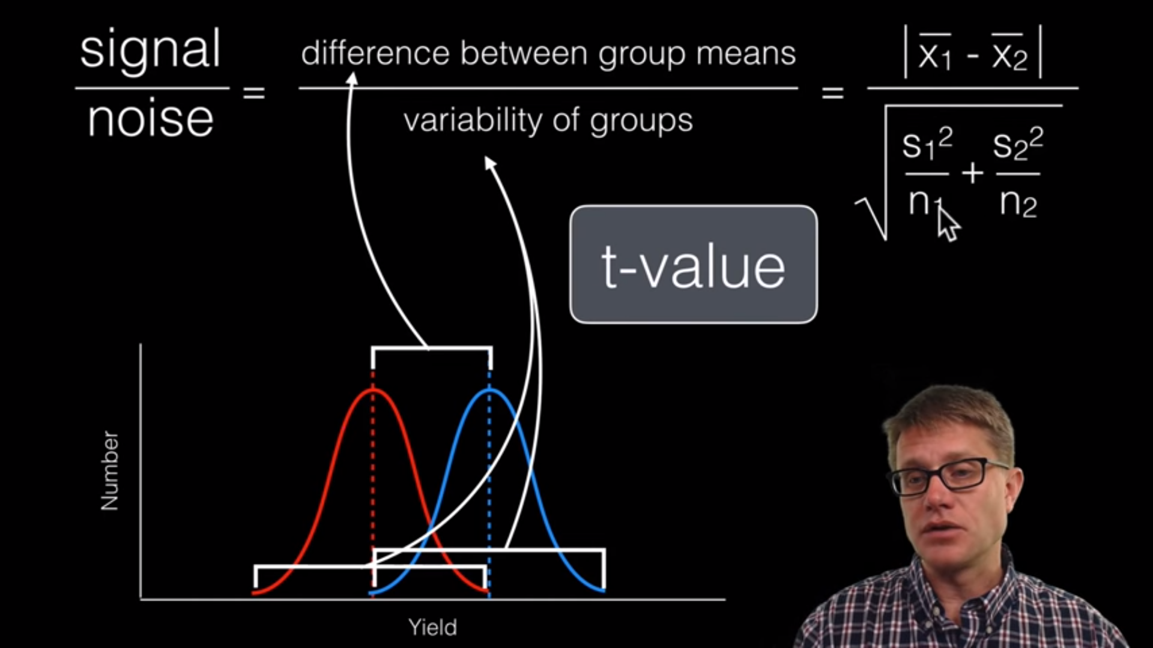

**>1, more signal than noise**

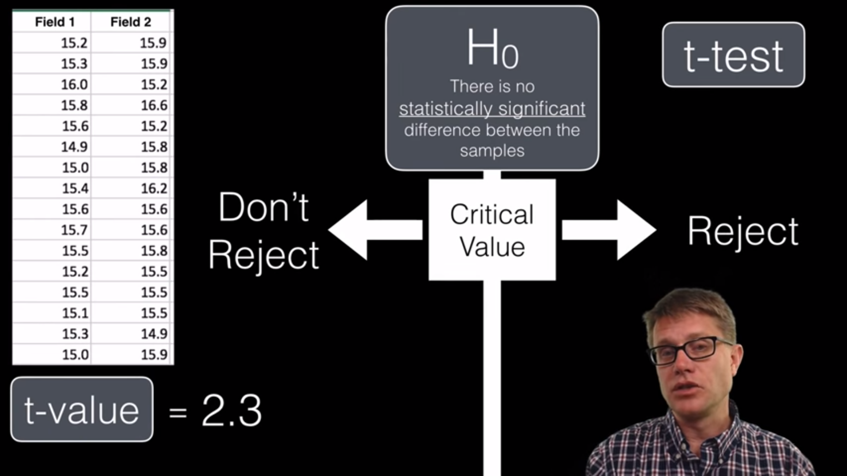

**Degrees of freedom p = 0.05: if we do this sample 100 times, 95% we will reject null hypothesis**

**Df = n1 + n2 – 2**

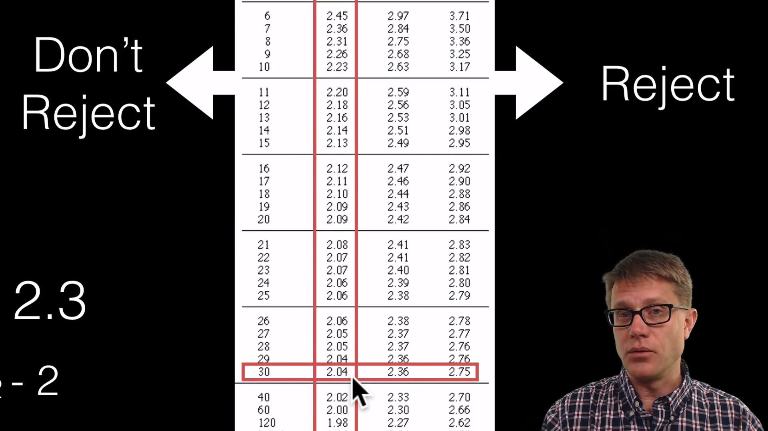

**t-value = 2.3 > 2.04 => reject h0 => there is difference**

[**https://www.khanacademy.org/math/statistics-probability/significance-tests-one-sample/more-significance-testing-videos/v/hypothesis-testing-and-p-values**](https://www.khanacademy.org/math/statistics-probability/significance-tests-one-sample/more-significance-testing-videos/v/hypothesis-testing-and-p-values)

**p-value: probability value, here the p-value is 0.003 means there’s a very small probability that we could have gotten this result if the null hypothesis was true, so we will reject it.**

